Kiosk Breakfast Hour SOP

Version 1.0
Date: 24 Oct 2025

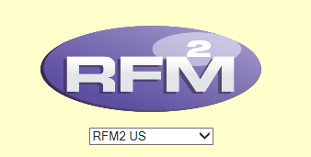

Revision History and Version Table

Version No. | Version Description | Author/ Date | Reviewers/ Date | Approving Party/ Date
0.1 | Revised document:  1. Change in Form Format  2. Updated checklist | Muskan Thakur/  24-10-2025 | Gautam Agarwal/  24-10-2025 | Gautam
1.0

Contents
Kiosk Breakfast Hour SOP 1
Revision History and Version Table 2
Purpose 3
Kiosk Breakfast Timings 3
Change in Form format 4
Survey Distribution to Team: 6
Kiosk Breakfast Hour Deployment Process: 6
Future Dated Changes 11
Validating Kiosk Breakfast 12
Tracking Kiosk Breakfast Hour 12
Apply Packages 12

Purpose
To guide team members through the end-to-end process of receiving, updating, validating, and tracking Kiosk Breakfast operational timings in RFM

Kiosk Breakfast Timings
Kiosk Breakfast comes under Field Survey Category along with the other two COO and store build. In Kiosk Breakfast, Generally the field only provides Breakfast daypart timings, and we need to update ROD timings based on that.

Change in Form format
Kiosk breakfast hour form is directly filled by store admins/users though the below provide MS form:
Link : Kiosk Breakfast Hours .
Below are the required fields which the store admin/ users can fill to get the Kiosk breakfast hour deployed in RFM. (See screenshots)
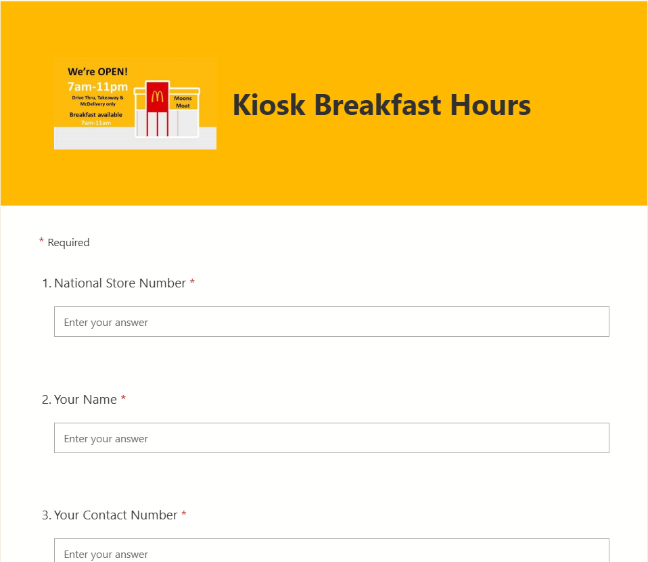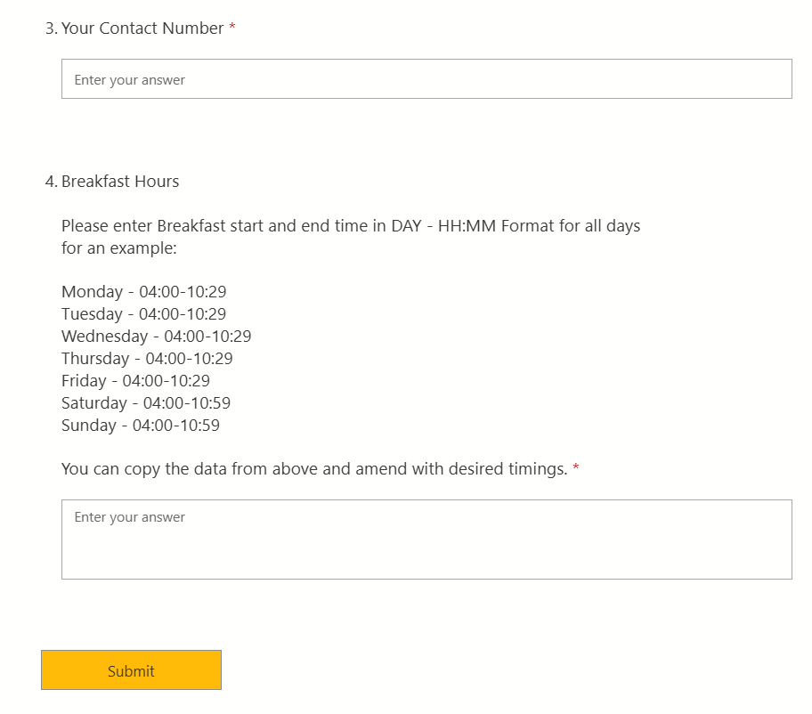
Then the person from US PCS team having admin rights of the above form, downloads all the survey responses received and share with the team to deploy the changes in RFM as per the requirement.
Survey Distribution to Team:
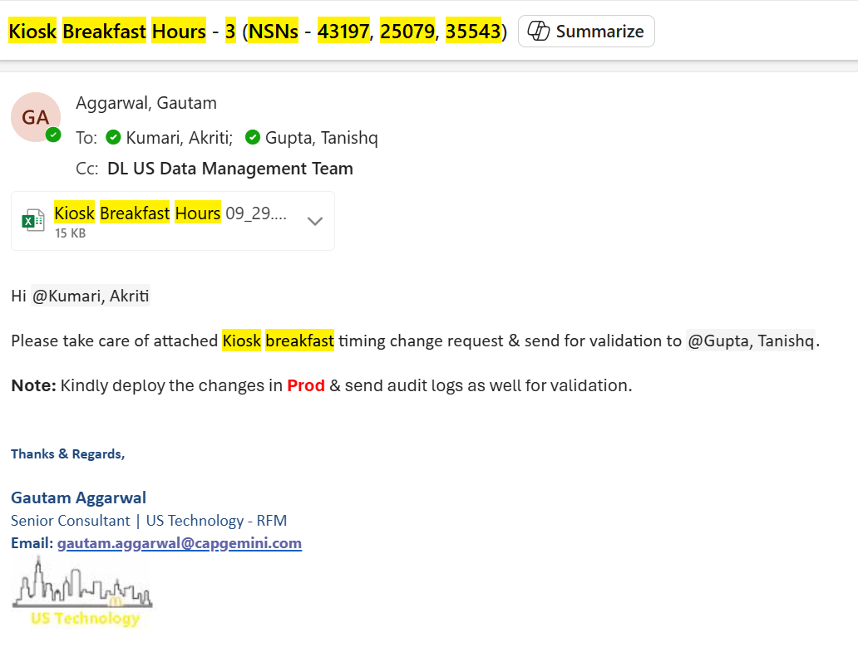

Referring to the image above, our team has received this survey in an email. we receive the form details in an Excel format. Below attached is the demo excel sheet and it shows the operational timings for the NSN #43197, Please note that once you receive an Kiosk Breakfast survey no effective date is mentioned, it means as soon as you receive it you are good to amend it in RFM. The survey only contains the breakfast timing, do not get confused about lunch and dinner as the latter will be according to the breakfast times only.

Kiosk Breakfast Hour Deployment Process:

- Login into RFM
- Click on Admin tab > Restaurant profile
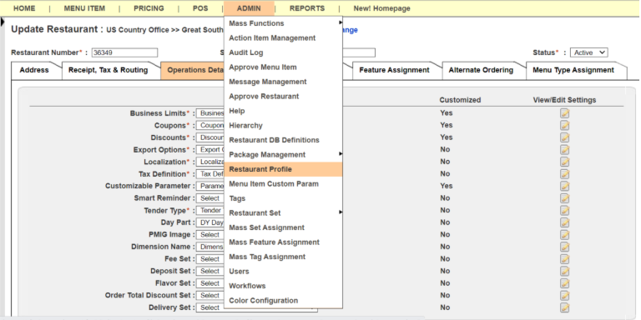
- In the Restaurant profile, enter the store number in the search tab and select Exact match and click search
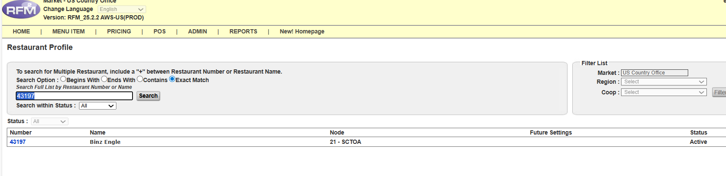
- Access the store by clicking the store number (Blue font)
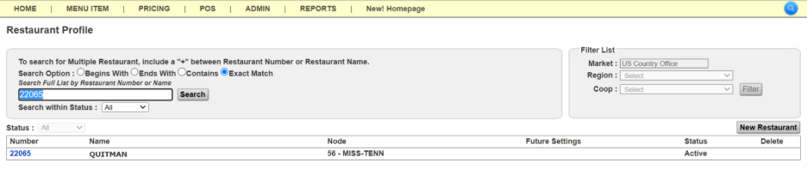
- Restaurant profile will open for NSN #43197
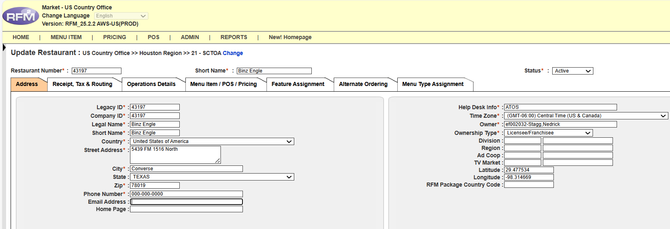

- Click on Operations details tab > Customizable parameter

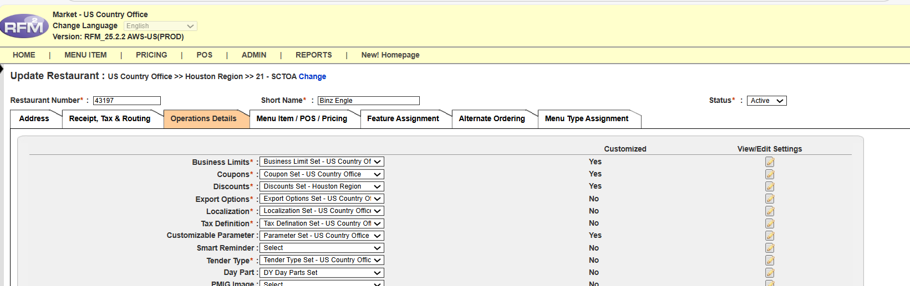

- New windows will open (Make sure your pop ups are not blocked)

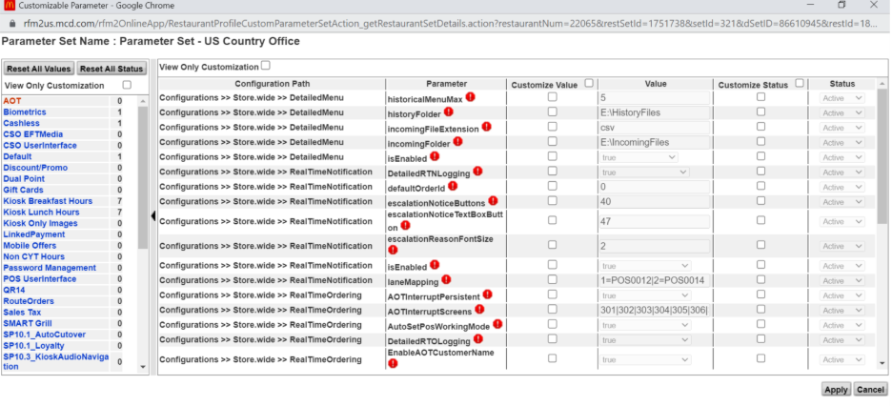
- Click on “Kiosk Breakfast Hours”
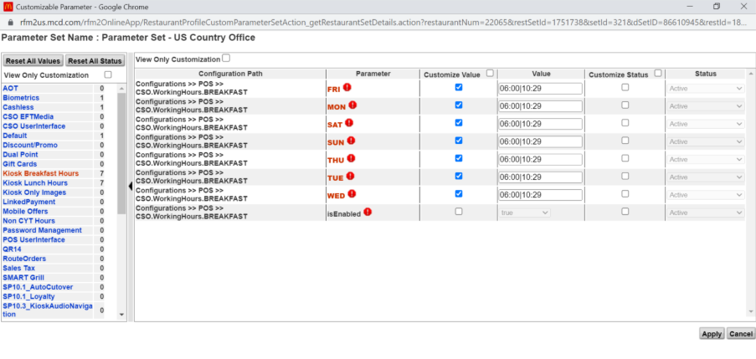
Please amend the timings as per the survey receive. Also, do not make any changes in “isEnabled” parameter. Click save once amended. (Starting time is exact time but end time is 10:29 because we keep 1 min as a buffer time)

- Click “Kiosk lunch hours”
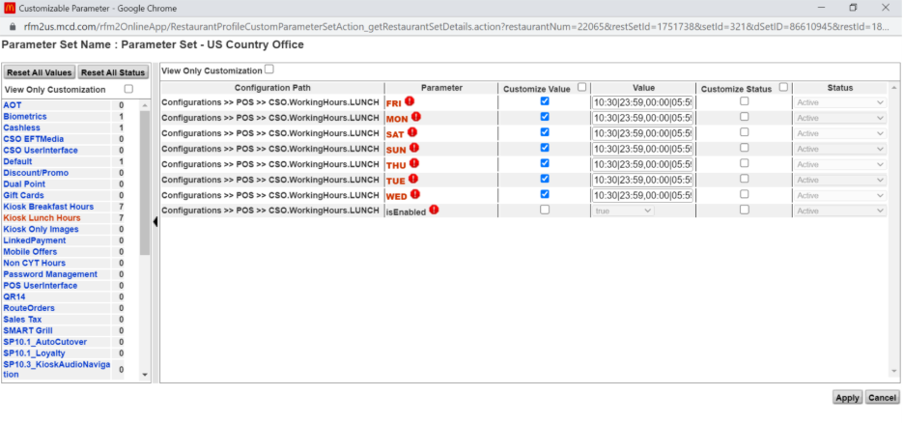
Amend the time here as well, 10:30 is start of lunch time and it goes up to 05:59 of next day (at 06:00 breakfast commences) . click Apply once amended.
- Click on “SP9-Kiosk6”
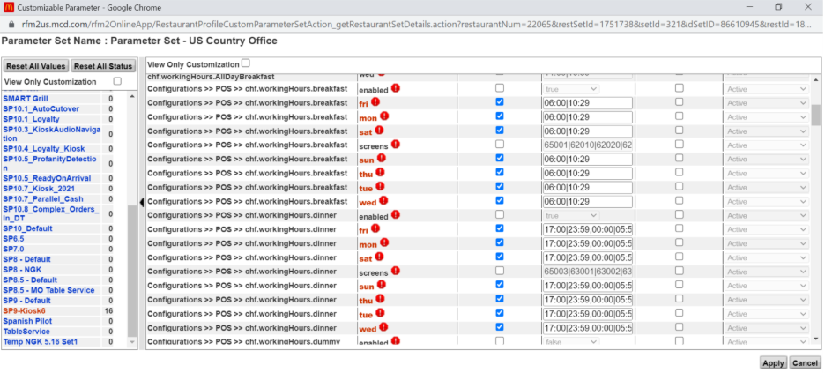
Amend chf.workinghours.breakfast ,chf.workinghours.lunch , chf.workinghours.dinner and chf.workinghours.latenight.
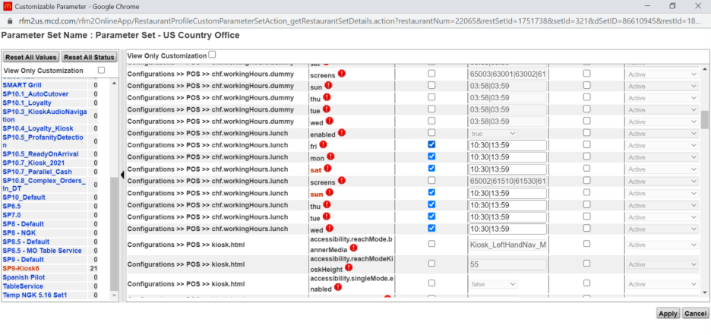
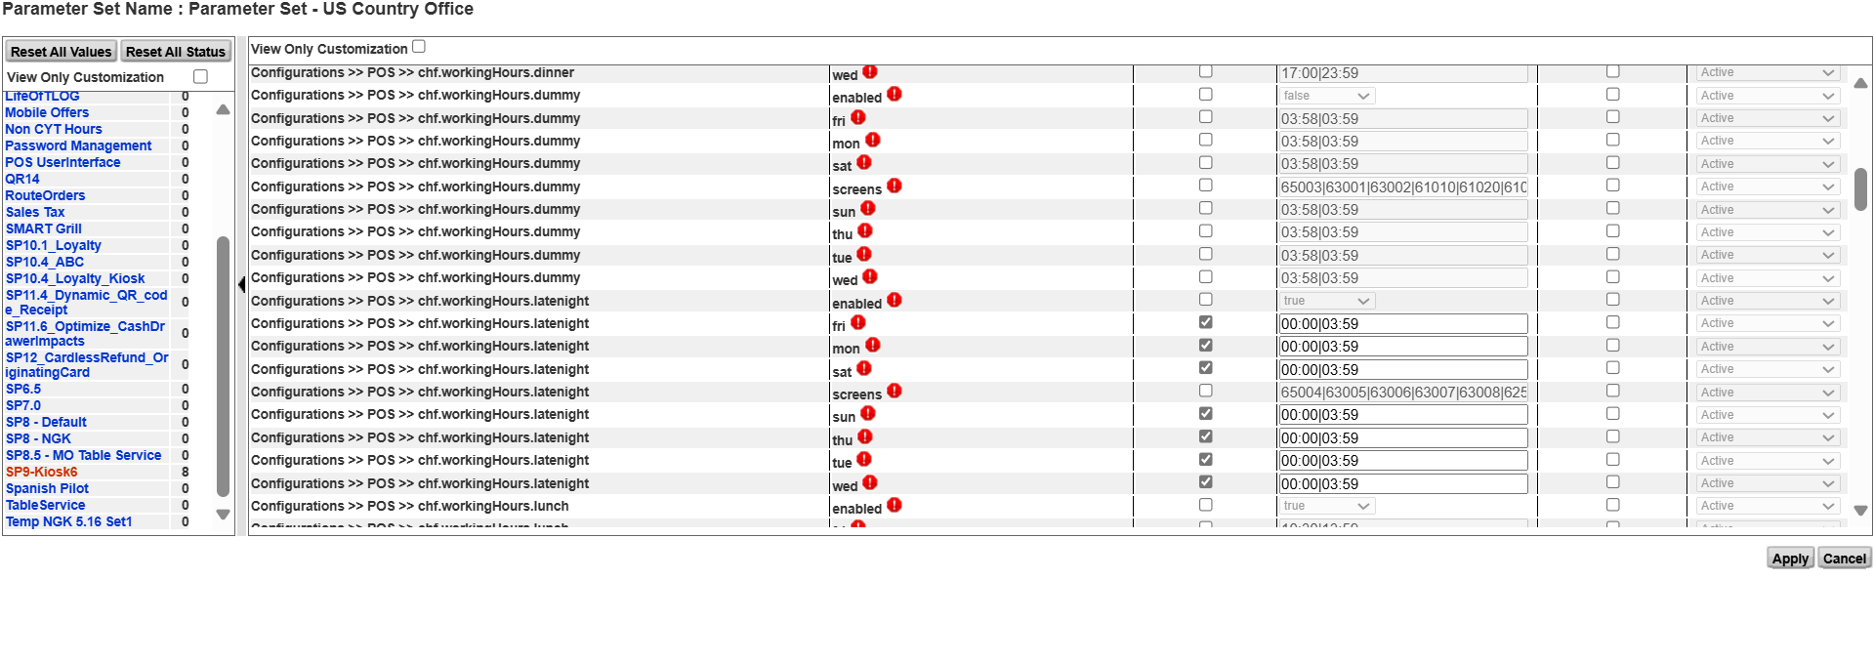
Do not touch the “screens” parameter while updating the hours. Once completed click apply.
- Press cancel to go back to the restaurant profile in the RFM and Kiosk Breakfast Hour completed

Future Dated Changes
Repeat the same process as mentioned above but while saving click on “future Date” and apply the date you want and then save it.
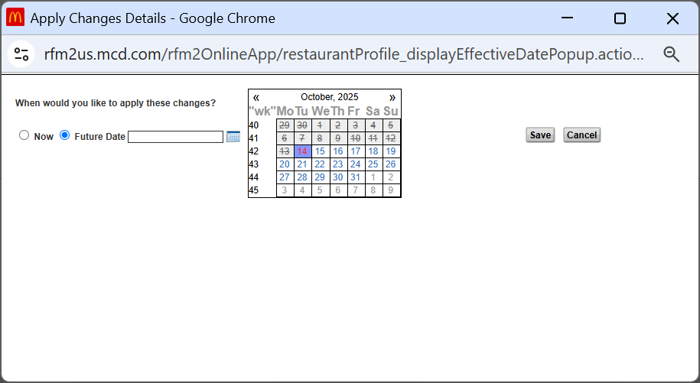

Validating Kiosk Breakfast
As per the process in RFM, whatever work we do it has to be validated thoroughly before we confirm or send the packages to the store so that the correct changes flow. Once you are done with your deployment kindly send the survey along with audit log to your validator for validation.
We validate the Kiosk Breakfast hour by three methods:
- Peer to Peer – Go to RFM and check the breakfast, lunch and SP9 Kiosk 6 tab if the correct timings have been deployed.
- Audit log – Check if the correct timings have been deployed using Audit log.
- Checklist – Always maintain the checklist while validating the work.

Tracking Kiosk Breakfast Hour
Post receiving the Validation email, kindly update the Kiosk Breakfast hour tracker so we can maintain the data and see if we have received this Store survey any time before.

Apply Packages
When everything is good, we will generate the RIDM package for the store and deliver it to the store so that the new timing can be reflected on store.

Created By,
Muskan Thakur
Muskan.thakur@capgemini.com
US – Technology RFM

